**School of Computer Science**

**UNIVERSITY OF PETROLEUM AND ENERGY STUDIES DEHRADUN, UTTARAKHAND**



System Provisioning And Configuration Management

Lab File (2022-2023)

for  
6th Semester

**SUBMITTED TO SUBMITTED BY**

DR. HITESH KUMAR SHARMA Alisha Parveen

B.TECH CSE – 6th SEM

DEVOPS - BATCH 1

500091204

**Lab Exercise 7– Creating Multiple IAM Users in**

**Terraform**

**Steps:**

**1. Create a Terraform Directory: **

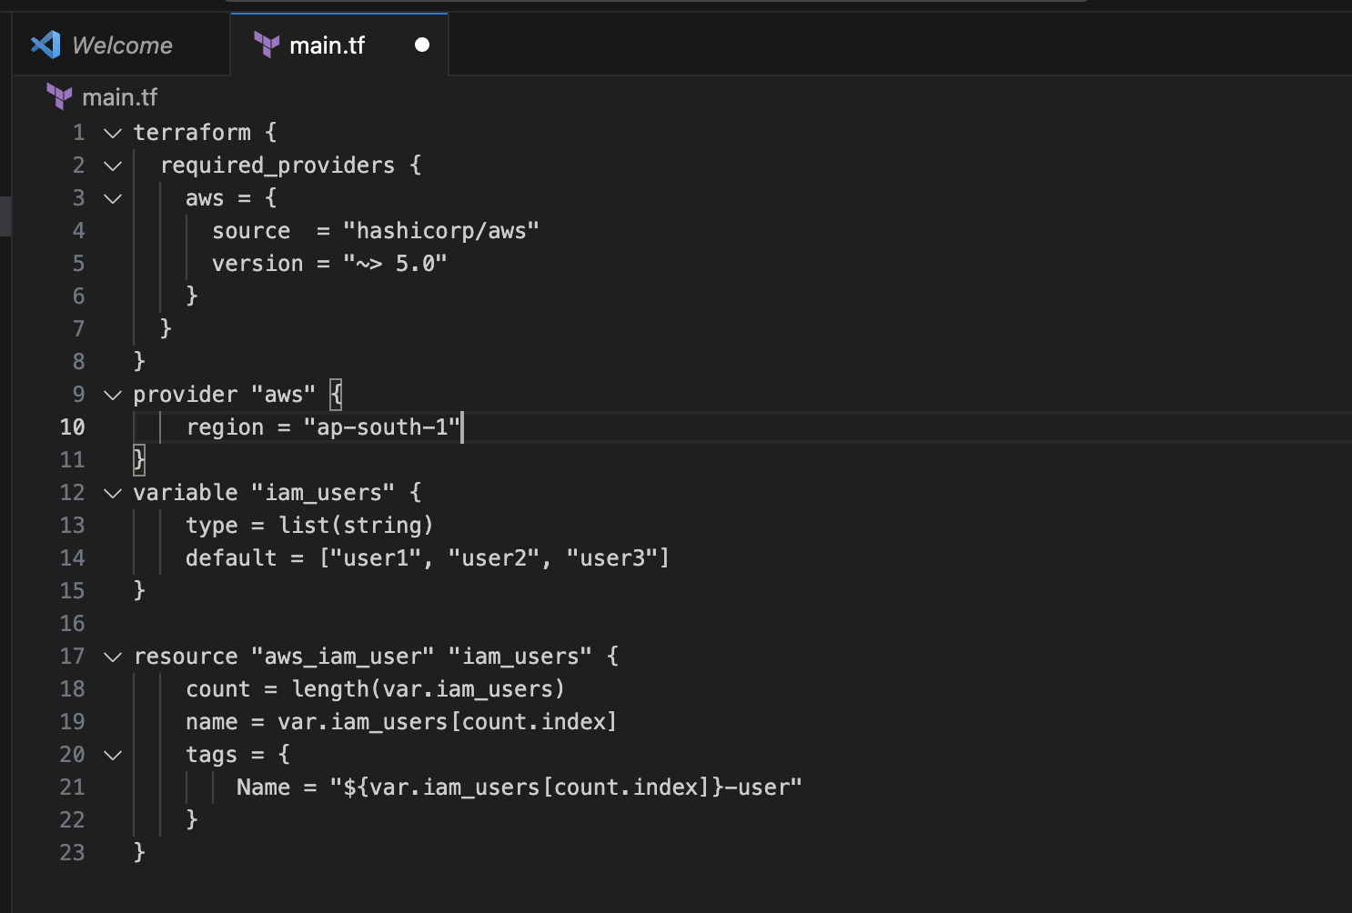

**2. Initialize and Apply:**

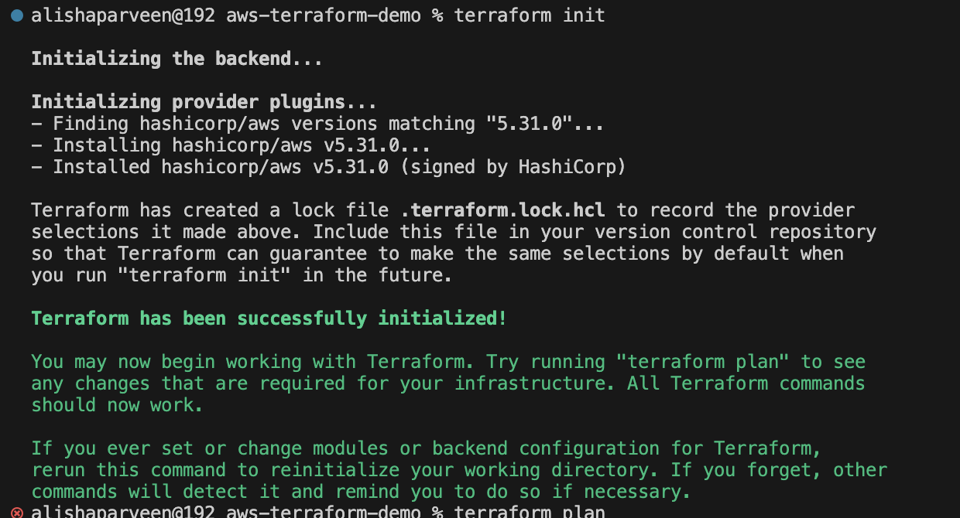

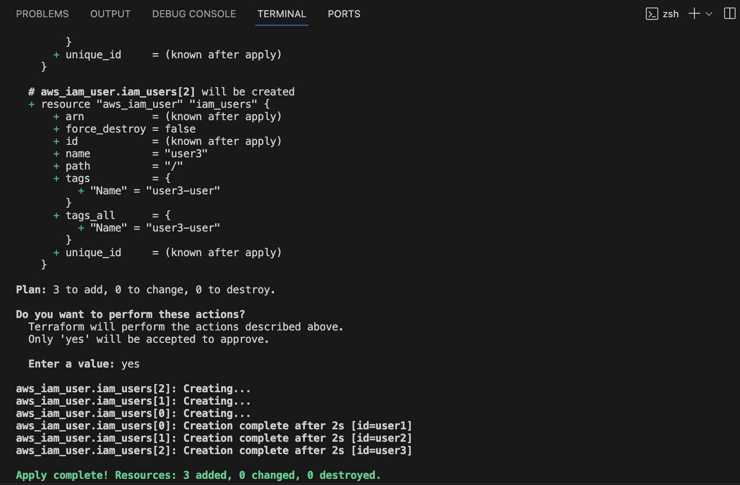

**3. Verify Users in AWS Console:**

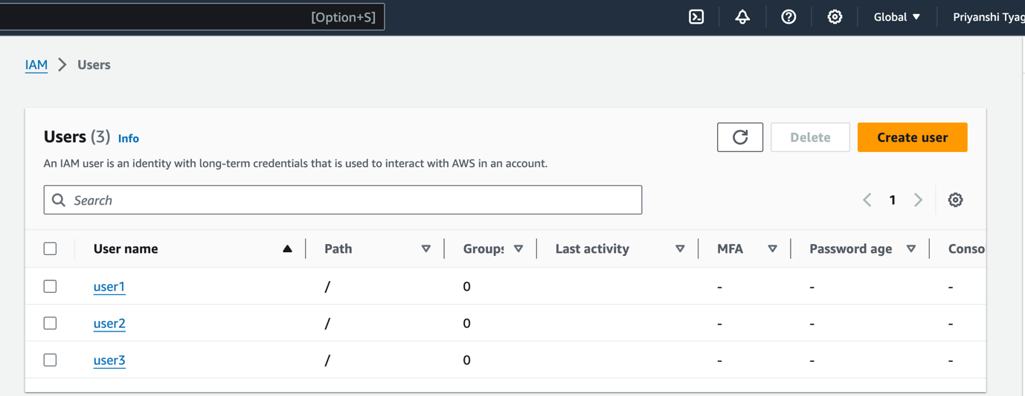

**4. Clean Up:**

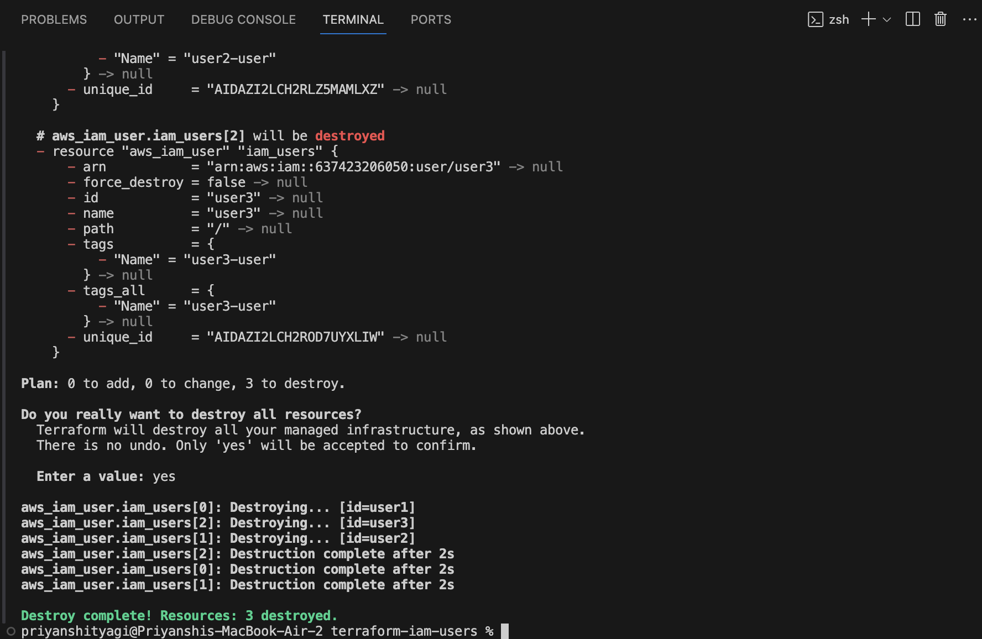

**Lab Exercise 8– Creating a VPC in Terraform Objective:**

**1. Create a Terraform Directory:**



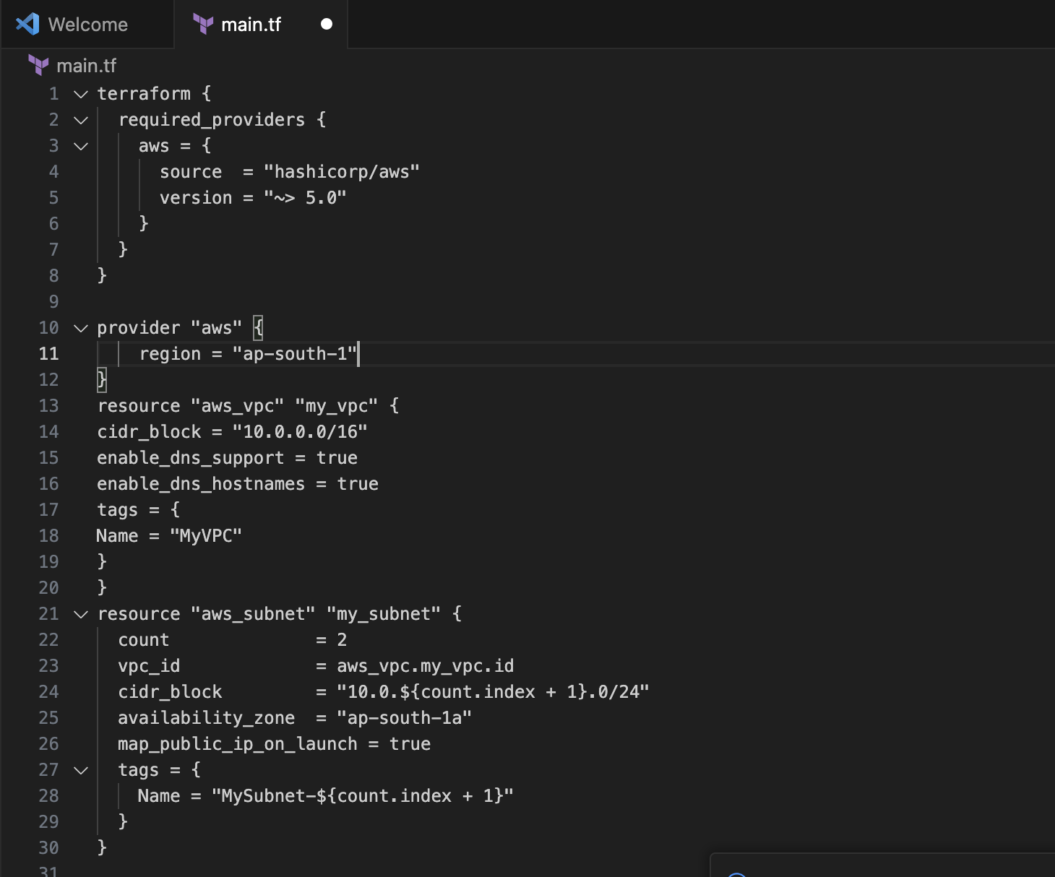

**2. Initialize and Apply:**

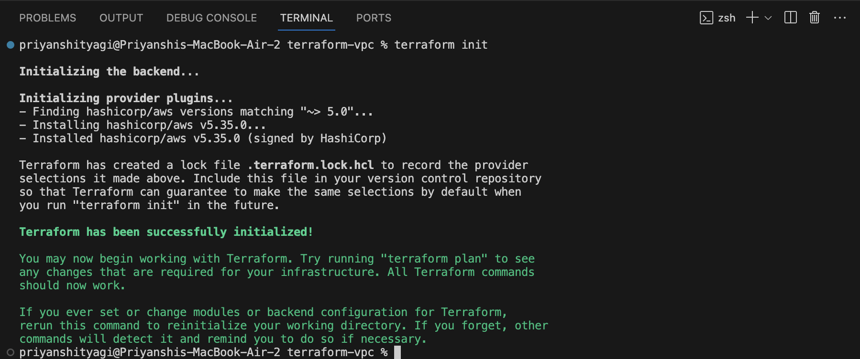

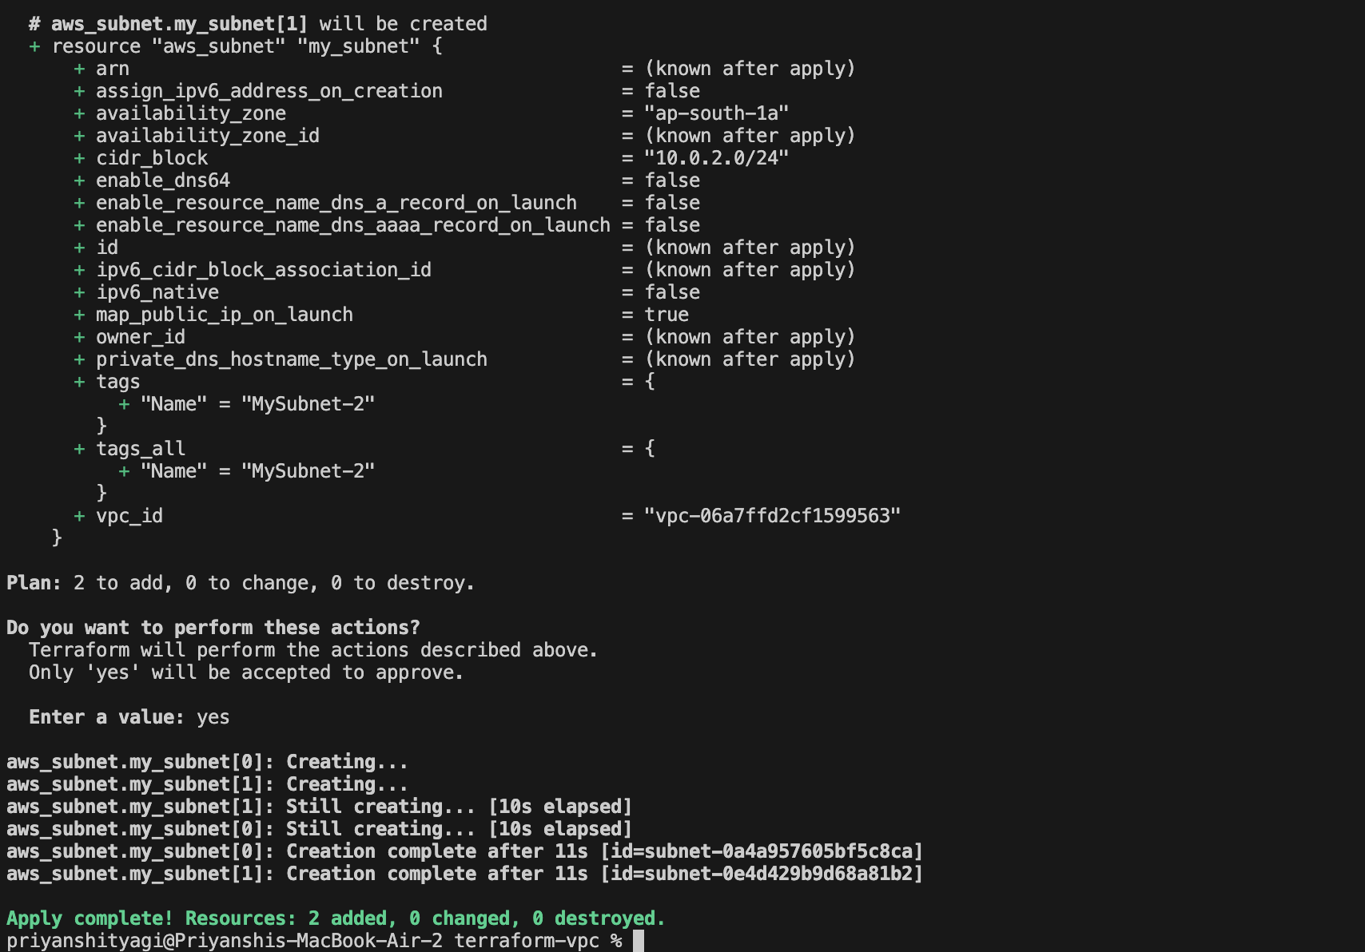

**3. Verify Resources in AWS Console:**

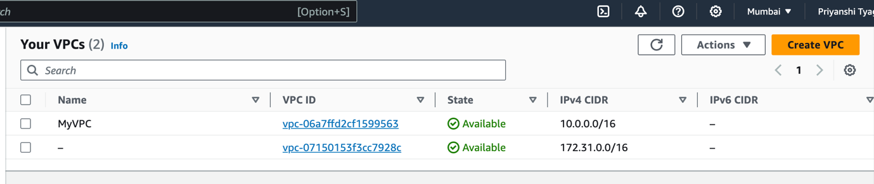

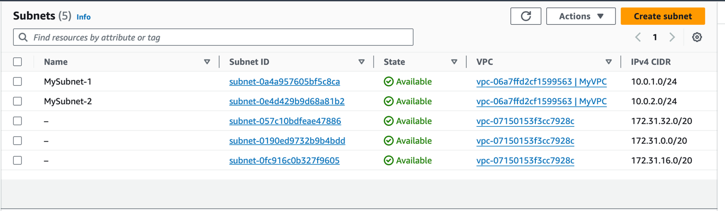

**4. Clean Up:**

